

**Simplified models for gas exchange for lungs of human body**



**Presented to:**

Doctor/Mai Atef, Eng/Ruwaa Saber

**Team members:**

* Shrouk Hesham 19106271
* Login Darwish 19105985
* Toqa Hamdy Goda 1910665
* Nada Elsayed Farghly 19106094
* Omar Mohamed Abdelrazik 19106149

**Abstract**

A hierarchy of models for gas exchange in the human lungs is presented in this research. This paper is concerned with the interactions via the gas exchange process. A hierarchy of very simple models for gas exchange in the human lungs is presented in this study. In humans, complex connections between the respiratory system and cardiac output have been discovered in several experiments. The models presented in this study may be thought of as a controlled system, and they give a mathematical foundation for connecting molecular-level and systems-level models. The effect of modifications in the molecular level on the alveolar partial pressure is illustrated. In addition, validating numerical simulations of the flexible lung model with gas exchange. Identifying methods we used in this model, using OpenCOR tool and finding results for our models. In this work, the gas exchange process is referred to as a controlled system. Numerical results are consistent with published experimental observations.

**Table of contents**

Abstract………………………………………………………………………………………….2

List of figures……………………………………………………………………………………4

1.Introduction……………………………………………………………………………………5

Part of the respiratory system………………………………………………………………….5

2.Literature Review……………………………………………………………………………..8

Lung anatomy…………………………………………………………………………………8

The respiratory system…………………………………………………………………………8

how do we breath……………………………………………………………………………….9

methods of gas exchange in human lungs……………………………………………………….10

Does the Respiratory System Clean the Air……………………………………………………..11

Our body use Inhalation and Exhalation processes……………………………………………12

3.Methodology………………………………………………………………………………….14

4.Results……………………………………………………………………………………..…18

5.Discussion……………………………………………………………………………………23

6.Conclusion………………………………………….………………………………………..24

7.Future Recommendations……………………………………………………………………25

8.References……………………………………………………………………………………26

.

**List of figures:**

figure 1: The lungs in human body ……………………………………………6

figure 2: The respiratory system (the muces)…… ……………………………8

figure 3: Anatomy of the respiratory system…………………………………..9

figure 4: the blood partial pressure readings are changed…………………….12

figure 5: the blood partial pressure readings are re-initialized………………..13

figure 6: Shows oxygen partial pressure in the alveoli……………………….15

figure 7: carbon dioxide partial pressure in the lobes……………………… 17

figure 8: use the flexible lung model with gas exchange when………………18

figure 9: the effect of blood flow on oxygen partial pressure in the blood…….20

figure 10: the effect of blood flow on carbon dioxide partial pressure in the blood….21

figure 11: Simulations of the flexible lung model with gas exchange and gas transport…23

figure 12: final result using OpenCOR tool for all of our graphs………………………23

1. **Introduction**

In this study, a system of models for gas exchange in the human lungs is presented. The respiratory system is the system in which the organs and other parts of our body involved in breathing when you exchange oxygen and carbon dioxide**.**

**Parts of the Respiratory System**

our respiratory system includes your:

* Nose and nasal cavity
* Sinuses
* Mouth
* Throat (pharynx)
* Voice box (larynx)
* Windpipe (trachea)
* Diaphragm
* Lungs
* Bronchial tubes/bronchi
* Bronchioles
* Air sacs (alveoli)
* Capillaries.

The human gas-exchanging organ, the lung, is located in the thorax, where its delicate tissues are protected by the bony and muscular thoracic cage. The purpose of this study is knowing the process of the gas exchange in the human lungs. the importance of this research is to know the activation of the human lungs in gas exchange. The mechanism of breathing is when you inhale air via your nose or mouth, you are breathing. It passes through the back of your throat and into your windpipe, which is split into bronchial tubes, which are air channels. Also, these airways must be open in order for your lungs to function properly. The lung provides the tissues of the human body with a continuous flow of oxygen and clears the blood of the gaseous waste product, carbon dioxide. Atmospheric air is pumped in and out regularly through a system of pipes, called conducting airways. There are two types of airway systems: upper and lower airway systems. The junction between both the two systems is found at the top of the larynx, where the respiratory and digestive systems' pathways move. In addition, Carbon dioxide is transported from the bloodstream to the lungs at the same moment. This occurs in the lungs, between the alveoli and a network of small blood arteries known as capillaries, which are found in the alveoli's walls.

Diffusion is the main source of gas exchange during respiration. Diffusion is a transport process that is influenced by a concentration gradient. Gas molecules travel from a high-concentration region to a low-concentration zone. In the lungs, blood with a low oxygen concentration and a high carbon dioxide concentration exchanges gases with air. Furthermore, the oxygen content of the air in the lungs is higher than that of oxygen-depleted blood. During respiration, this concentration gradient allows for gas exchange. The size of a human's lungs is determined by heredity, gender, and height. A typical lung can store nearly six liters of air at maximum capacity, yet lungs rarely work at this level. Lung volumes and capacities are used to measure the amount of air in the lungs. Patients with lung and cardiovascular illnesses are evaluated and treated by respiratory therapists or respiratory practitioners. They design treatment strategies for patients as part of a medical team. Patients with chronic illnesses such as asthma, as well as preterm babies with underdeveloped lungs, may be treated by respiratory therapists; lung disease, such as emphysema and chronic obstructive pulmonary disease. Therefore, A hierarchy of models for gas exchange in the human lungs is presented in this research.

1. **Literature Review**

The lungs are the center of the respiratory (breathing) system.

Every cell of the body needs oxygen to stay alive and healthy. Your body also needs to get rid of carbon dioxide. This gas is a waste product that is made by the cells during their normal, everyday functions. Your lungs are specially designed to exchange these gases every time you breathe in and out.

**Lung anatomy**

This spongy, pinkish organ looks like two upside-down cones in your chest. The right lung is made up of three lobes. The left lung has only two lobes to make room for your heart.

**The respiratory system**

The lungs are the main part of the respiratory system. This system is divided into the upper respiratory tract and the lower respiratory tract.

The upper respiratory tract includes the:

* **Mouth and nose.** Air enters and leaves the lungs through the mouth and nostrils of the nose.
* **Nasal cavity.** Air passes from the nose into the nasal cavity, and then the lungs.
* **Throat (pharynx).** Air from the mouth is sent to the lungs via the throat.
* **Voice box (larynx).** This part of the throat helps air to pass into the lungs and keeps out food and drink.

The lower respiratory tract is made up of the:

* lungs
* trachea (windpipe)
* bronchi
* bronchioles
* alveoli

Other parts of the respiratory system help your lungs to expand and contract as you breathe. These include the ribs around the lungs and the dome-shaped diaphragm muscle below them.

The lungs are surrounded by your sternum (chest bone) and ribcage on the front and the vertebrae (backbones) on the back. This bony cage helps to protect the lungs and other organs in your chest.

**How do we breathe?**

* Breathing starts when you inhale air into your nose or [mouth](https://www.webmd.com/oral-health/ss/slideshow-mouth-problems). It travels down the back of your throat and into your windpipe, which is divided into air passages called bronchial tubes.
* For our [lungs](https://www.webmd.com/lung/rm-quiz-lungs-quiz) to perform their best, these airways need to be open.  They should be free from [inflammation](https://www.webmd.com/arthritis/about-inflammation) or swelling and extra mucus.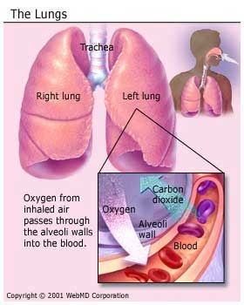 As the bronchial tubes pass through your lungs, they divide into smaller air passages called bronchioles. The bronchioles end in tiny balloon-like air sacs called alveoli. Your body has about 600 million alveoli.
* The alveoli are surrounded by a mesh of tiny [blood](https://www.webmd.com/heart/anatomy-picture-of-blood) vessels called capillaries. Here, oxygen from inhaled air passes into your [blood](https://www.webmd.com/a-to-z-guides/rm-quiz-blood-basics).
* After absorbing oxygen, blood goes to your [heart](https://www.webmd.com/heart/picture-of-the-heart). Your [heart](https://www.webmd.com/heart-disease/rm-quiz-know-heart) then pumps it through your body to the cells of your tissues and organs

As the cells use the oxygen, they make carbon dioxide that goes into your blood. Your blood then carries the carbon dioxide back to your lungs, where it’s removed from your body when you exhale.

**Methods of gas exchange in human lungs**

The primary function of the [respiratory system](https://www.merckmanuals.com/home/lung-and-airway-disorders/biology-of-the-lungs-and-airways/overview-of-the-respiratory-system) is to take in oxygen and eliminate carbon dioxide. Inhaled oxygen enters the lungs and reaches the alveoli. The layers of cells lining the alveoli and the surrounding capillaries are each only one cell thick and are in very close contact with each other.

Oxygenated blood travels from the lungs through the pulmonary veins and into the left side of the heart, which pumps the blood to the rest of the body

Three processes are essential for the transfer of oxygen from the outside air to the blood flowing through the lungs: ventilation, diffusion, and perfusion.

* Ventilation is the process by which air moves in and out of the lungs.
* Diffusion is the spontaneous movement of gases, without the use of any energy or effort by the body, between the alveoli and the capillaries in the lungs.
* Perfusion is the process by which the cardiovascular system pumps blood throughout the lungs.

**Does the Respiratory System Clean the Air?**

Your respiratory system has built-in methods to keep harmful things in the air from entering your lungs.

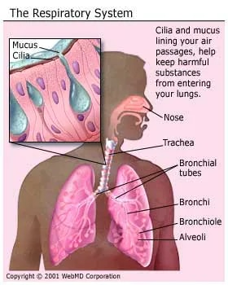Hairs in your nose help filter out large particles. Tiny hairs, called cilia, along your air passages move in a sweeping motion to keep the passages clean. But if you breathe in harmful things like cigarette smoke, the cilia can stop working. This can lead to health problems like [bronchitis](https://www.webmd.com/lung/understanding-bronchitis-basics).

Cells in your trachea and bronchial tubes make mucus that keeps air passages moist and helps keep things like dust, bacteria and viruses, and [allergy](https://www.webmd.com/allergies/default.htm)-causing things out of your lungs. Mucus can bring up things that reach deeper into your lungs. You then cough out or swallow them.

**Our body use Inhalation and Exhalation processes:** Inhalation and exhalation are how your body brings in oxygen and gets rid of carbon dioxide. The process gets help from a large dome-shaped muscle under your lungs called the diaphragm.When you breathe in, your diaphragm pulls downward, creating a vacuum that causes a rush of air into your lungs.

The opposite happens with exhalation: Your diaphragm relaxes upward, pushing on your lungs, allowing them to deflate.

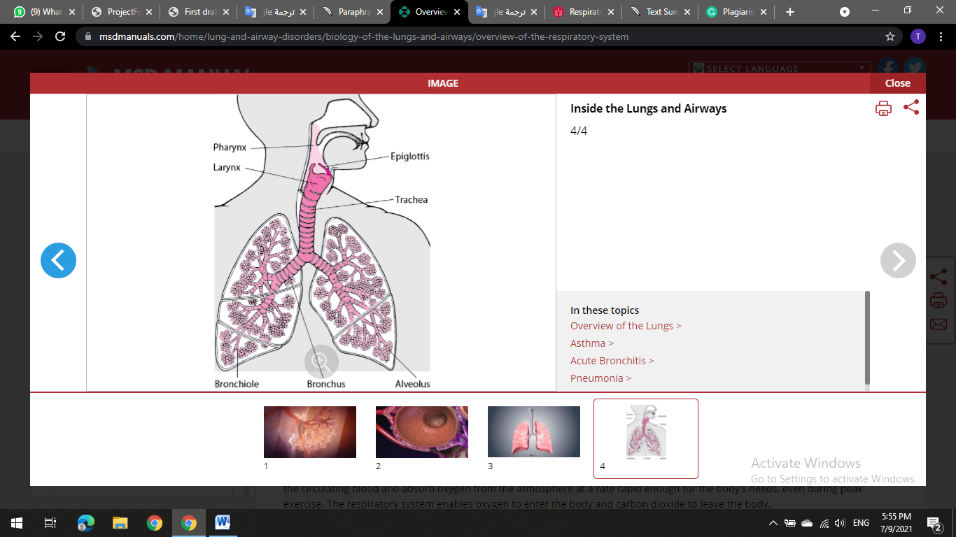

The body must produce enough energy to maintain life. The respiratory system allows oxygen and carbon dioxide to enter and exit the body. At peak exercise, the human body requires an organ system that can remove carbon dioxide from the circulating blood at a rate fast enough to meet the body's needs. The cells that line the alveoli and adjacent capillaries are only one cell thick and are in close proximity to one another. The lungs' oxygenated blood goes through the pulmonary veins to the left side of the heart, where it is pumped to the rest of the body. The blood is then rushed to the lungs via the pulmonary artery, picking up oxygen and exhaling carbon dioxide. The circulation of the body is a vital link between the atmosphere, which supplies oxygen, and the body's cells. The ability of the lungs to provide oxygen to muscle cells is dependent on the blood's ability to carry oxygen. A tiny portion of the blood pumped from the heart also enter the bronchial arteries.

COPD is a lung disease that makes it difficult to force air out of your lungs. The most common cause of COPD is smoking cigarettes according to the American Lung Association.

After we have a background for our system, a hierarchy of very simple models for gas exchange in the human lungs is presented in this study.

1. **Methods**

In our method section, we build a model of the gas exchange in human lungs that allows the the interactions via the gas exchange process. First, we chose the system then select the research paper we want to work on and our paper ides. After that, we build a mathematical model using OpenCOR to achieve our results. A hierarchy of very simple models for gas exchange in the human lungs is presented in this study

the materials we used (the model file and the software name)?

This CellML model runs in both PCEnv and COR.

**Variables used in our study:**

**Parameters used:**

**Mathematical models of the human lung:**

In this section a hierarchy of simplified models for the human lungs is presented. In all the models, the lung is described as a single container of air.

# Model Mathematics

1. **Results**

In this paper some of the findings are used to validate the models, while others are used to demonstrate the benefits of moving between models, and still others give new information on the physiological system.

Figure (4): Shows that every heartbeat, the blood partial pressure readings are changed.

**Result from the original paper:**

Figure (5): Shows a "moving" conveyor. (a) Every heartbeat, the blood partial pressure readings are re-initialized. (b) To determine the solutions at the end of the pulmonary capillaries, a sample of the solution is taken at the conclusion of each inter-beat interval.

Figure (6): Shows oxygen partial pressure in the alveoli.

Figure (7): Shows carbon dioxide partial pressure in the lobes.

**Result from the original paper:**

Figure (8): Shows that We use the flexible lung model with gas exchange when, (a) Oxygen partial pressure in the alveoli. (b) Carbon dioxide partial pressure in the lobes. the convergence time towards steady-state solutions is longer but the results do not change qualitatively).

Figure (9): Shows the effect of blood flow on oxygen partial pressure in the blood.

Figure (10): Shows the effect of blood flow on carbon dioxide partial pressure in the blood.

**Result from the original paper:**

Figure (11): Simulations of the flexible lung model with gas exchange and gas transport. (a) Effect of blood flow on blood partial pressure of oxygen. (b) Effect of blood flow on blood partial pressure of carbon dioxide.

Figure (12): Shows our final result using OpenCOR tool for all of our graphs.

1. **Discussion**

In this section, we provided a brief discussion for our results. Showing that as our heart beats faster, healthy blood vessels will expand in size to allow increased blood flow, which helps our blood pressure remain relatively stable. The oscillations are caused by the combined effects of heart rate and breathing frequency. This result serves to validate the numerical simulations of the flexible lung model with gas exchange, as shown in figs (4,5).

Then our results have shown that, alveolar partial pressure of oxygen (PAO2) Once air is warmed and humidified in the nose and upper respiratory tract, the pressure of oxygen decreases while concentration of H2O increases, thus altering effective PO2 in this gas mixture. PaCO2 is the carbon dioxide partial pressure in alveoli, in which impacts the available partial pressure of oxygen throughout the body. We use the flexible lung model with gas exchange when, (a) Oxygen partial pressure in the alveoli. (b) Carbon dioxide partial pressure in the lobes. the convergence time towards steady-state solutions is longer but the results do not change qualitatively). It can be observed that the partial pressures in the lung eventually equilibrate with the partial pressures of the blood, as shown in figs (6,7,8).

After that, our results have shown that, gas exchange and gas transport simulations using the flexible lung model. (a) The effect of blood flow on oxygen partial pressure in the blood. (b) The effect of blood flow on carbon dioxide partial pressure in the blood.it can be seen that an increase in cardiac output (a higher heart rate or a larger stroke volume) will reduce the alveolar partial pressure of oxygen (or increase the partial pressure of carbon dioxide) because more oxygen is taken up by hemoglobin (and more carbon dioxide is released), as shown in figs (9,10,11).

1. **Conclusion**

In these section after some of the results are used to validate the models, some are used to illustrate the advantage of moving between models and some provide new insights to the physiological system. the averaged models provided a qualitative explanation of the numerical results that were obtained by the more complex models. A hierarchy of very simple models for gas exchange in the human lungs is presented in this study. In this work, mathematical modelling is regarded as a dynamic process in which basic and detailed models are applied forwards and backwards on a continually. The relationships between the models in this paper have been established. The idea that simplified models are simpler to understand and provide insight to the system. This study makes a number of assumptions, one of which is that the process of oxygen binding to hemoglobin is close to equilibrium. The fact that the models in this paper may be simplified to simpler models and known models was used to both analytically and quantitatively validate the models.

1. **Future work**

In Future work, the models in this paper can be connected to more complicated lung models. For example, a three-dimensional model of the conducting airways might be linked to the models in this research. Gas exchange is regarded in this paper as the controlled system. While studying the controlled system can provide some insight into the cardio-respiratory system, the control and feedback mechanisms are important for understanding synchronization and Cheyne–Stokes’s respiration and will be covered in the future.

1. **References**

* Grodins, F.S., Buell, J., Bart, A.J., 1967. Mathematical analysis and digital simulation of the respiratory control system. J. Appl. Physiol. 22 (2), 260–276.
* Huang, N.S., Hellums, J.D., 1994. A theoretical model for gas transport and acid/base regulation by blood flowing in microvessels. Microvasc. Res. 48, 364–388
* Kalamangalam, G.P., 1995. Nonlinear oscillations and chaos in chemical cardiorespiratory control. Ph.D. Thesis, University of Oxford, UK, <http://www.maths.ox.ac.uk/research/theses/>
* Lu, K., Clark Jr., J.W., Ghorbel, F.H., Ware, D.L., Bidani, A., 2001. A human cardiopulmonary system model applied to the analysis of the Valsalva maneuver. Am. J. Physiol. Heart Circ. Physiol. 281, H2661–H2679
* McFadden Jr., E.R., Denison, D.M., Waller, J.F., Assoufi, B., Peacock, A., Sopwith, T., 1982. Direct recordings of the temperatures in the tracheobronchial tree in normal man. J. Clin. Invest. 69, 700–705.
* Mead, J., Whittenberger, J.L., Radford Jr., E.P., 1957. Surface tension as a factor in pulmonary volume–pressure hysteresis. J. Appl. Physiol. 10 (2), 191–196.
* Carley, D.W., Shannon, D.C., 1988. A minimal mathematical model of human periodic breathing. J. Appl. Physiol. 65 (3), 1400–1409. Comroe, J.H., 1975. Physiology of Respiration, second ed. Year Book Medical Publishers, Inc.
* Brittain, T., Simpson, R., 1989. An analysis of the stopped-flow kinetics of gaseous ligand uptake and release by adult mouse erythrocytes. Biochem. J. 260, 171–176.
* Fowler, A.C., Kalamangalam, G.P., 2002. Periodic breathing at high altitude. IMA J. Math. Appl. Med. 19, 293–313.
* Galletly, D., Larsen, P., 1999. Ventilatory frequency variability in spontaneously breathing anaesthetized subjects. Br. J. Anaesth. 83 (4), 552–563.